**Supplemental Material**

**Supplement to:**

DNA metabarcoding reveals within-season variation in the diet of the insectivorous black-throated blue warbler (Setophaga caerulescens)

*Corresponding author:* Sara Kaiser Cornell Laboratory of Ornithology, Cornell University, Ithaca, NY, USA Email: [sak275@cornell.edu](mailto:sak275@cornell.edu)

**Table S1.** Frequency of occurrence (%) of all prey species identified in the diets of black-throated blue warblers by survey period at the Hubbard Brook Experimental Forest, New Hampshire, USA.

**Table S2.** Frequency of occurrence (%) of all prey family identified in the diets of black-throated blue warblers by survey period at the Hubbard Brook Experimental Forest, New Hampshire, USA.

**Figure S1.** NMDS plot of diet composition shows A) limited overlap between the diets of black-throated blue warblers sampled during the mid and late survey periods and B) some overlap across elevation zones at the Hubbard Brook Experimental Forest, New Hampshire, USA. Points represent diet composition of individuals based on species. Ovals represent standard error (???).

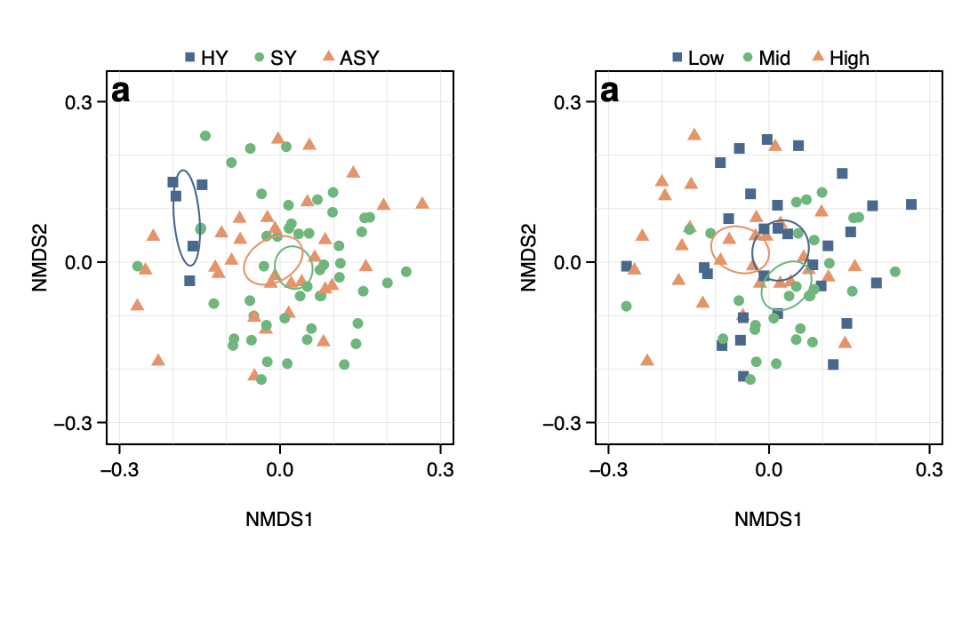

**Figure S2.** BeeSwarm of per-sample species richness shows limited differences between the diets of black-throated blue warblers between survey periods at the Hubbard Brook Experimental Forest, New Hampshire, USA. Points represent the number of species per sample split by survey period.

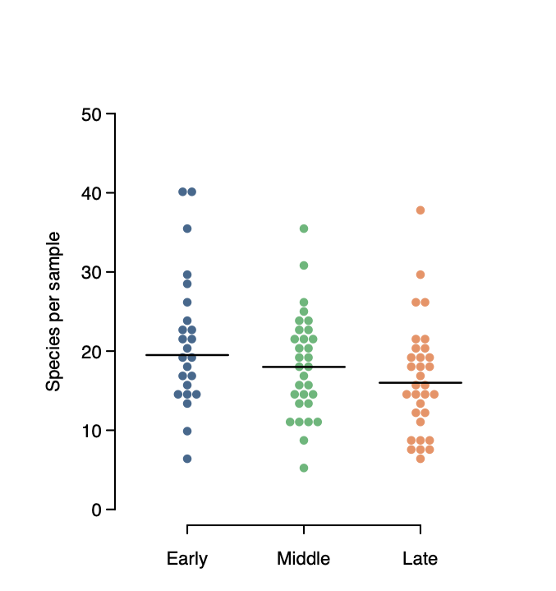

**Figure S3.** Comparison of the frequency of occurrence of prey items in the diets of black-throated blue warblers with capture frequency of the most common arthropod families identified in Malaise traps at the Hubbard Brook Experimental Forest, New Hampshire, USA.

